Biology subject B

In all kingdoms of life, transcription factors (TFs) regulate gene expression by site-specific binding to chromosomal DNA, pre-venting or promoting the transcription by RNA polymerase. The lac operon of Escherichia coli, a model system for understanding TF-mediated transcriptional control, has been the subject of extensive biochemical, structural, and theoretical studies since the seminal work by Jacob and Monod. However, the in vivo kinetics of the lac repressor, and all other TFs, has only been studied indirectly by monitoring the regulated gene products. Traditionally, this was done on a population of cells, in which unsynchronized gene activity among cells masks the underlying dynamics. Recent experiments on single cells allow investigation of stochastic gene expression. However, direct observation of TF-mediated gene regulation remains difficult, because it often involves only a few copies of TFs and their chromosomal binding sites. Here we report on a kinetics study of how fast a lac repressor binds its chromosomal operators and dissociates in response to a metabolic signal in a living E. coli cell.
Single-molecule detection also makes it possible to investigate how a TF molecule searches for specific binding sites on DNA, a central question in molecular biology. Target location by TFs (and most nucleic acid binding proteins) is believed to be achieved by facilitated diffusion, in which a TF searches for specific binding sites through a combination of one-dimensional (1D) diffusion along a short DNA segment and 3D translocation among DNA segments through cytoplasm. However, real-time observation in living cells has not been available because of technical difficulties. Here we report on such an investigation, providing quantitative information of the search process.
The lac repressor (LacI) is a dimer of dimers. Under repressed conditions one dimer binds the major lac operator, O1, and the other dimer binds one of the weaker auxiliary operators, O2 or O3 (Fig. 1A). LacI binding to O1 prevents RNA polymerase from transcribing the lac operon (lacZYA). Upon binding of allolactose, an intermediate metabolite in the lactose pathway, or a nondegradable analog, such as IPTG (isopropyl b-D-1-thiogalactopyranoside), the repressor’s affinity for the operator is substantially reduced to a level comparable to that of nonspecific DNA interaction.
To image the lac repressor, we expressed it from the native chromosomal lacI locus as a C-terminal fusion with the rapidly maturing (~7 min) yellow fluorescent protein (YFP) Venus (A206K) (Fig. 1A). The short maturation time prevents the lac operator sites from being occupied by immature fusion proteins. The C-terminal fusion avoids interference with the N-terminal DNA binding domain.

Question 1: Define the term “operon”

Question 2: Explain what a fusion protein is.

Question 3: Describe the general principal of fluorescence imaging using fluorescent proteins.

Question 4: On figure 1C, how do you explain the presence of either one or two fluorescent spots in each bacteria?

Question 5 : In order to determine whether the LacI-Venus fusion forms a dimer instead of a tetramer in vivo, the authors constructed an E. coli strain (JE14) with only one LacI dimer binding site (O1). Considering there is no significant binding to O2 site, from figure 2, can you tell whether the fusion protein bind as a dimer or a tetramer?

Question 6: Explain briefly the molecular event taking place in figure 3 A and B.
Question 7: What can you conclude from figure 3 C and D in terms of non specific residence time on DNA of IPTG LacI-Venus

Figure 1
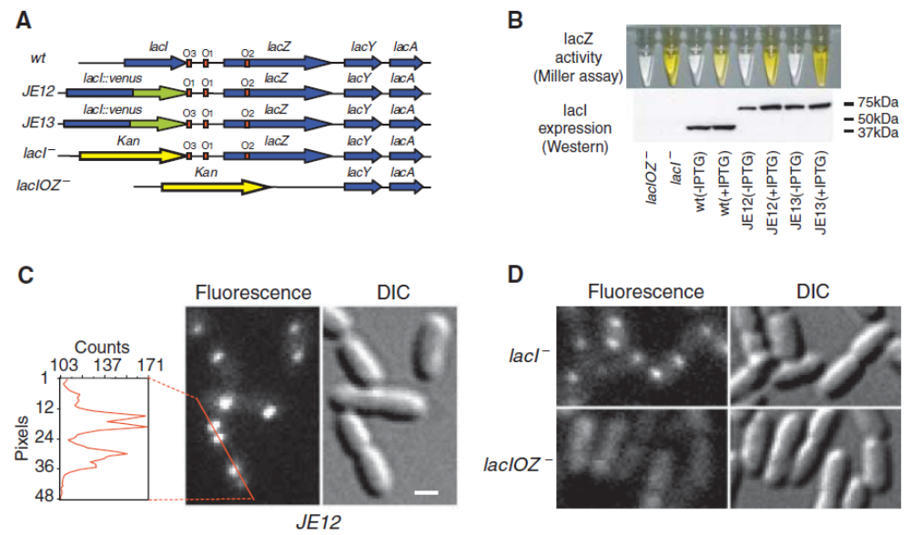

Figure 2
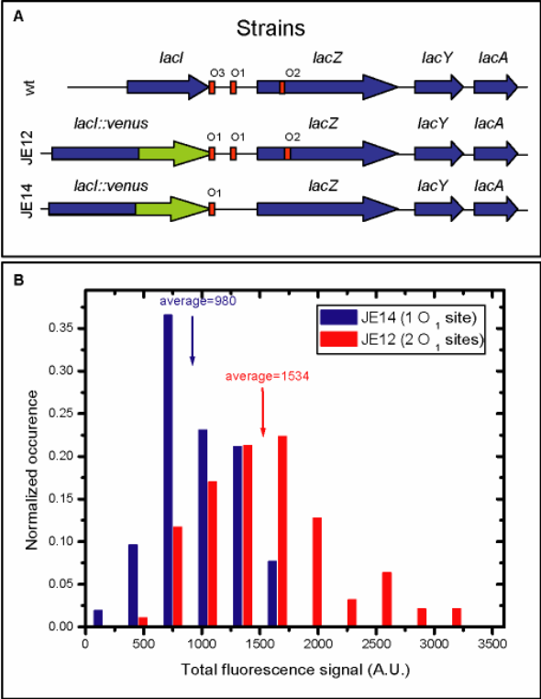

Figure 3
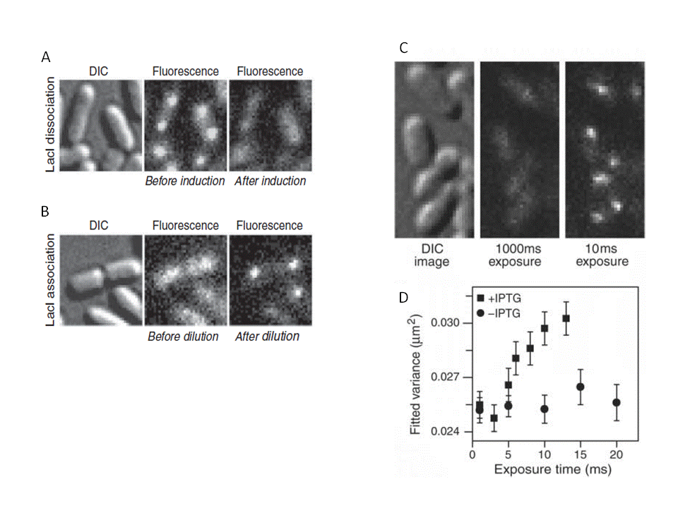
(A) JE12 bacteria before and 40 s after addition of IPTG to a final concentration of 1 mM. (B) JE12 bacteria before and 1 min after dilution of IPTG from 100 to 2 µM with the addition of 1mM ONPF (2-nitrophenyl-b-D-fucoside) an anti-inducer that competitively binds to LacI. (C) Two fluorescence images with different exposure times and the corresponding DIC image of IPTG-induced E. coli cells. At 1000 ms, individual LacI-Venus appear as diffuse fluorescence background. At 10 ms they are clearly visible as nearly diffraction-limited spots. (D)Fluorescence spot size as a function of exposure time. The size is represented as the average variance of a 2D Gaussian function fit to images of fluorescence spots (±SEM, n~ 100). The same total excitation energy is used for different exposure time. The spots are measured before (−IPTG,●) and after (+IPTG,■) induction.

